**Conversion of Wasted Heat Energy into Electrical Energy Using TEG**

**Chowdhury Erfan Shourov, Abdullah Al Mahmood and Noor E Alam Siddique**

**Faculty Advisor: Dr. Hasan Uz Zaman**

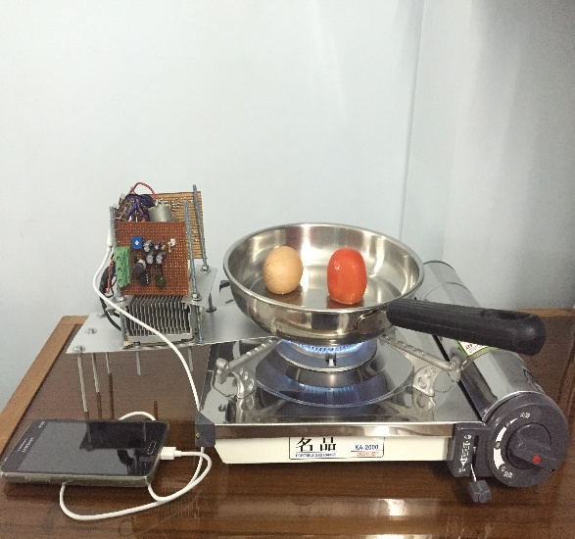

Figure: The designed system shown in an application

Bangladesh is a country, which occupies an area of 1, 47,000 sq. km with 85% of it being rural. In these areas, there are places where electricity is in paucity and/or is unstable. However, the usages of mobile phones are a common scenario despite of the scarcity of electricity involved. It is rare to find a person does not own a mobile phone. Charging cell phones is quite the turmoil when electricity is this unstable in these regions. Our prime concern was people who do not have access to stable electricity.

The main concept was to build a system, which would charge up cell phones while being cooked, which is a quotidian taking place at least 3 times or even more in Bangladesh. In short, the system converts wasted heat energy while cooking into electrical energy to charge up a cell phone.

The results were pretty successful. The mobile phone starts to charge after 50 seconds and the fan turns after 1 min. The long legibility and the duration of how long the charging can be done have not been determined yet because of time constraint of the course. There are lot more areas where the system can be worked on for being more efficient. The functionality of the system was successfully implemented and the mobile phone was charged.